**To create React App (We shall do it using vite)**

* PS D:\MERN\MERNwithSigninSignup> npm create vite@latest client
  + - Select React
    - Select JavaScript+SWC
* PS D:\MERN\MERNwithSigninSignup> cd .\client\
* PS D:\MERN\MERNwithSigninSignup\client> npm I //For installation
* Search **tailwind css vite >> goto first link (**[**https://tailwindcss.com/docs/guides/vite**](https://tailwindcss.com/docs/guides/vite)**)**
  + - Follow the steps in the link
      * PS D:\MERN\MERNwithSigninSignup\client> npm install -D tailwindcss postcss autoprefixer
      * PS D:\MERN\MERNwithSigninSignup\client> npx tailwindcss init –p
      * Configure your template paths: Add the paths to all of your template files in your tailwind.config.js file.
      * Add the Tailwind directives to your CSS: Add the @tailwind directives for each of Tailwind’s layers to your ./src/index.css file.
      * Clean the folder structure delete unwanted files from the folder : *.svg files, App.css

**Install some important VS code extensions**

* ES7+ React/Redux/React-Native/JS snippets
* Tailwind CSS IntelliSense
* Prettier - Code formatter

**App.jsx:**

import React from 'react'

export default function App() {

  return (

    <div>

      <h1>Hello buddy</h1></div>

  )}

**GIT Integration:**

* PS D:\MERN\MERNwithSigninSignup> git init
* PS D:\MERN\MERNwithSigninSignup> git add .
* PS D:\MERN\MERNwithSigninSignup> git commit -m 'install reactjs and tailwind css'
* Go to github.com and create a repo as follows:

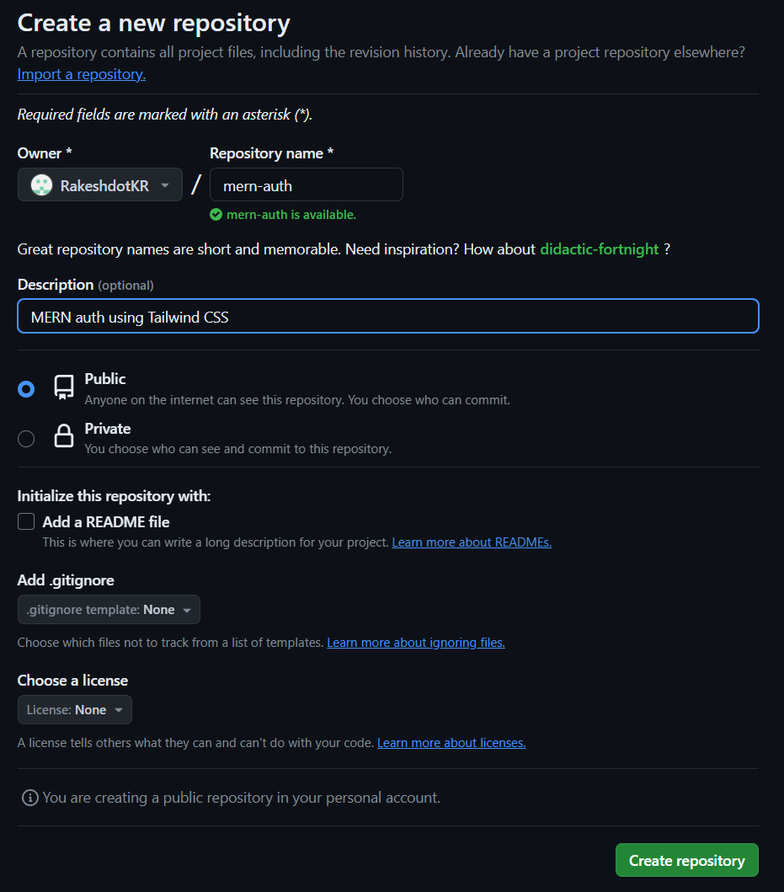

Run following commands in terminal:

PS D:\MERN\MERNwithSigninSignup> git remote add origin https://github.com/RakeshdotKR/mern-auth.git

PS D:\MERN\MERNwithSigninSignup> git branch -M main

PS D:\MERN\MERNwithSigninSignup> git push -u origin main

Create **pages** folder and create following files: client\src\pages

* SignIn.jsx
* SignUp.jsx
* About.jsx
* Home.jsx
* Profile.jsx

**Adding Navigation**

PS D:\MERN\MERNwithSigninSignup\client> npm i react-router-dom //for adding navigation

**App.jsx:**

import { BrowserRouter, Routes, Route } from "react-router-dom";

import Home from "./pages/Home";

import About from "./pages/About";

import SignIn from "./pages/SignIn";

import SignUp from "./pages/SignUp";

import Profile from "./pages/Profile";

export default function App() {

  return (

    <BrowserRouter>

      <Routes>

        <Route path="/" element={<Home/>}/>

        <Route path="/about" element={<About/>}/>

        <Route path="/sign-in" element={<SignIn/>}/>

        <Route path="/sign-up" element={<SignUp/>}/>

        <Route path="/profile" element={<Profile/>}/>

      </Routes>

    </BrowserRouter>

  );

}

**Now whenever we need to commit the changes to GitHub do the following:**

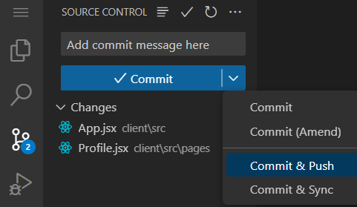

**Adding Header Component:**

client\src\components\Header.jsx:

**import { Link } from "react-router-dom";**

**export default function Header() {**

**return (**

**<div className="bg-slate-300">**

**<div className="flex justify-between items-center max-w-7xl mx-auto p-3">**

**<Link to="/">**

**<h3 className="font-semibold">Auth App</h3>**

**</Link>**

**<ul className="flex gap-3">**

**<Link to="/">**

**<li>Home</li>**

**</Link>**

**<Link to="/about">**

**<li>About</li>**

**</Link>**

**<Link to="/sign-in">**

**<li>Sign In</li>**

**</Link>**

**</ul>**

**</div>**

**</div>**

**);**

**}**

**The Backend**

**Create & run the server**

Create a folder called as ‘api’ in the root folder:

In terminal:

* PS D:\MERN\MERNwithSigninSignup\api> npm init –y
* PS D:\MERN\MERNwithSigninSignup\api> npm install express nodemon

//to be added in package.json

"scripts": {

    "dev": "nodemon index.js",

    "start": "node index.js"

  },

PS D:\MERN\MERNwithSigninSignup\api> npm run dev //to run server

**api\index.js:**

import express from "express"; //Add this line in package.json "description": "","type":"module",

const app = express();

app.listen(3000,()=>{

    console.log("Server listening on port 3000");

});

Connect to Database

PS D:\MERN\MERNwithSigninSignup\api> npm i mongoose

PS D:\MERN\MERNwithSigninSignup\api> npm i dotenv

Errors:

1. MongooseError: The `uri` parameter to `openUri()` must be a string, got "undefined". Make sure the first parameter to `mongoose.connect()` or `mongoose.createConnection()` is a string.

Solution:

* Make sure the .env file is in the same location as the index.js
* And in the .env file it should be like follows (not within quotes)
  + MONGOURI = mongodb://127.0.0.1:27017/mern-auth;